Establishing Nitrogen Credits Following a Sweet Corn Crop

Carl Rosen¹, James Crants¹, Matt McNearney¹, Vince Fritz² and Charlie Rohwer²
¹Department of Soil, Water and Climate and ²Southern Research and Outreach Center

Summary
Previous research has found that sweet corn stover can provide 70 to 77 lbs/ac N with a C:N of 32:1 to 35:1. Sweet corn stover may therefore supply an N credit to any subsequent crop. However, because sweet corn is typically harvested in August, much of that N may be lost if a cover crop is not planted after harvest. The objective of this two-year study is to determine the N credit for field corn from a previous crop of sweet corn with and without a cover crop of rye planted after the sweet corn crop, compared to using soybeans or field corn as the rotation crop. In each of four blocks, four whole plots were planted in 2017 (in Field 1) and, in a separate field (Field 2), in 2018 with one of four crops: (1) field corn, (2) soybeans, (3) sweet corn, and (4) sweet corn with a rye cover crop planted after harvest. In the field started in 2017, field corn was planted in 2018 in every plot, and each plot was divided into subplots receiving N as urea at planting at six rates: 0, 50, 100, 150, 200, and 250 lbs/ac N, all applied preplant in the spring. The results reported here are the set-up year in each field and the field corn year in Field 1. Rotation crop yields were higher in 2018 than 2017, probably due to a cold, wet spring in 2017. In Field 1, the rye cover crop contained about 50 lbs/ac N with a C:N of about 14:1 at the time it was disked in in May 2018. In both fields, field corn produced more stover, but with a lower N concentration (0.6%) and higher C:N (73:1) than the other rotation crops. Soybean straw had a lower N concentration (1.0%) and higher C:N (50:1) than sweet corn stover (1.5% N, 30:1 C:N). In each year, the amount of N removed from the field at harvest was highest with soybeans (174 lbs/ac N, on average), followed by field corn (100 lbs/ac N), then sweet corn (38 – 39 lbs/ac N). In contrast, the amount of N left in the field in above-ground stover or straw was lowest for soybeans (42 lbs/ac N, on average), with field corn and sweet corn leaving similar amounts of N to each other (about 45 – 65 lbs/ac N). In Field 1, the end-of-season soil NO₃-N concentration (0-2 feet) was highest in plots planted with sweet corn without rye, and the concentration in soybean plots had converged with that of sweet corn plots without rye by the following spring. However, in Field 2, the end-of-season soil NO₃-N was lowest in plots planted in sweet corn without rye. In the field corn season in Field 1, yield, N concentration, and N content per acre of all above-ground tissues increased with the application rate of N, as expected, except that cob tissue also had high N concentrations at the lowest N rates (0 and 50 lbs/ac N). Field corn yield, N concentration, and N content per acre and end-of-season soil NO₃-N were all consistently higher in plots previously planted in sweet corn, with or without rye, than plots previously planted in field corn. Plots planted in soybean were similar to field corn plots in stover yield, stover N concentration, and stover N content per acre, but similar to sweet corn plots in grain yield, grain N content per acre, and end-of-season soil NO₃-N. The EONR in plots previously planted in field corn was far higher (248 lbs/ac N) than those calculated for plots previously planted in sweet corn (178 lbs/ac N) or soybeans (160 lbs/ac N), and sweet corn with rye had a lower EONR than sweet corn alone (162 lbs/ac N). Overall, our results, based on one year of data, indicate that sweet corn provides an N credit to a subsequent field corn crop that is similar to or slightly smaller than the N credit provided by soybeans. In addition, the difference in the N credit between sweet corn and soybeans based on EONR analysis was closed when the rye cover crop was planted, indicating that the cover crop may increase the N credit that sweet corn provides.

Background
Based on our previous research, sweet corn stover can contain 70 to 77 lbs/ac N with a C:N between 32:1 and 35:1 when N was applied at a rate of 120 lbs/ac. These results suggest that incorporating sweet corn stover into the field after harvest may provide an N credit for field corn grown the following season.
The objective of this study is to assess the effect of soil-incorporated sweet corn stover, relative to field corn and soybean stover (which have C:N ratios of >50:1 and 30-50:1, respectively), on the N response of field corn grown the following season. We hypothesize that sweet corn, unlike field corn, will provide an N credit for field corn grown the following year, that this N credit will be smaller than that of soybeans, and that a rye cover crop will conserve some N from sweet corn stover that would otherwise be lost. In this report, we report on the amount of N and the C:N of the stover of field corn, soybean, sweet corn, and sweet corn followed by rye grown in two fields, one in 2017 (hereafter, “Field 1”) and one in 2018 (“Field 2”), as well as the N response of field corn in 2018 following each of these crops in Field 1.

Materials and methods
The study is being conducted on Nicolett-Webster clay loam soils at the Southern Research and Outreach Center in Waseca, MN. The previous crop in each field was field corn. Selected soil characteristics from each field both before and after rotation crops were grown are presented in Table 1.
Treatments were applied in a randomized complete block split-plot design with treatments as summarized in Table 2. In each field, 16 whole plots, each 126 feet long and 30 feet wide, were each planted with one of four crops in 2017 (Field 1) or 2018 (Field 2): field corn, soybeans, sweet corn, or sweet corn followed by winter rye. The cultivars planted were Nutech 5F-503AM blend at 34,237 seeds/ac (field corn), Asgrow AG1733 at 151,050 seeds/ac (soybeans), and Syngenta GSS1477 at 23,702 seeds/ac (sweet corn). N was applied to the corn plots in the rotation-crop year as urea (46-0-0) at 170 lbs/ac for field corn plots and 140 lbs/ac for sweet corn plots. Soybeans did not receive urea. Urea applications for the rotation-crop year were made on May 5, 2017, in Field 1 and May 18 and 25, 2018 (field corn and sweet corn, respectively) in Field 2. In Field 1, field corn and sweet corn were planted on May 8, 2017, and soybeans were planted on May 11, 2017. In Field 2, field corn was planted on May 18, 2018, with soybeans on May 24 and sweet corn on May 25. At planting in 2017, 7.5 lbs/ac N and 25.7 lbs/ac P₂O₅ were applied to the field corn and sweet corn plots as 6.5 gal/ac ammonium polyphosphate (10-34-0). No starter was applied in 2018. Between June 6 and 15, 2017, areas in the Field 1 sweet corn plots that had poor emergence due to cold, wet conditions were hand-planted to target population density. This was not necessary in 2018. Harvest dates were October 18 – 22, 1917, and October 23, 2018, for field corn; August 15 in each year for sweet corn; and October 19, 2017, and October 24, 2018, for soybeans. Sweet corn plots without rye were chisel plowed following the sweet corn harvest. Sweet corn plots with rye were not chisel plowed. The rye cover crop in the sweet corn/rye plots was planted in late August in 2017 and early September in 2018 using a no-till drill. The rye planted in 2017 was disked on May 10, 2018, treated with glyphosate on May 15, and disked again on May 18. Steps in the rye crop’s management are illustrated in Figures 2 through 9.
In the second year of planting in Field 1, field corn was planted in every whole plot, and each whole plot was divided into six subplots receiving 0, 50, 100, 150, 200, or 250 lbs/ac N as urea at planting. All plots received 60 lbs/ac P₂O₅, 60 lbs/ac K₂O, and 15 lbs/ac S as a blend of triple superphosphate, MOP, and gypsum on May 16, 2018. The field corn was planted and urea fertilizer applied on May 21 and harvested on October 23.
Yield from each crop except rye was determined in a five-foot-wide strip 42 feet long in the center of each subplot. Rye yield was estimated from six, one-square-foot areas in each whole plot. In the sweet corn and field corn plots, stover yield and tissue N concentrations were measured in six representative plants per subplot. In the soybean plots, whole plants (including seeds) were collected from eight linear feet of row (a 20-square-foot area) to determine whole-plant yield, N concentration, and N uptake. Seed N concentrations were measured for a subsample of the seed yield sample and used to calculate N uptake into the seed. Straw yield and N uptake were estimated by subtracting the values for seed from the values for whole plants, and straw N concentration was estimated by dividing the estimate for N uptake by the estimate for dry yield. Soil samples were collected from the top two feet of each main plot following field corn harvest (November 7). Samples were air dried, ground, and analyzed for nitrate-N.
Results for the rotation years in the two fields were analyzed as functions of field, rotation crop, their interaction, and block using the MIXED procedure in SAS 9.4, with denominator degrees of freedom calculated by the Kenward-Roger method. Pairwise comparisons between treatments were made using the LSMEANS statement with the /DIFF option. Results for the field corn year in Field 1 were analyzed as functions of previous crop, N rate, their interaction, and block using the same methods applied to the rotation year data. The economically optimum N rate (EONR) was calculated by plotting crop revenue per acre (crop yield times November 2018 prices for each crop) minus N cost per acre (N application rate per acre times the November 2018 per-pound cost of N as urea) as a function of the application rate of N for field corn following each rotation crop. A quadratic equation was fitted to the data for each previous crop, and the point of the curve where additional N no longer increased net crop revenue (crop revenue minus N cost) was calculated for each curve. This point was identified as the EONR.

Results and discussion
Rotation crops
Yields for field corn, soybeans, and sweet corn in each year are presented in Table 3. All three crops had higher yields in 2018 than 2017. This difference is probably due to colder, wetter spring conditions in 2017 compared to 2018. The yield, N content, N uptake, and C:N of winter rye residues in the corn-rye plots of Field 1 as of May 8, 2018, are presented in Table 4. The N content of the aboveground rye residue was about 50 lbs/ac, and the C:N was about 14:1, indicating that winter rye has good potential to sequester N in a form that is fairly accessible to microbial decomposition.
Stover yield, N uptake, and soil N results for all three rotation crops are presented in Table 5. Most of the variables measured showed significant year*crop effects, though some of the differences among crops were consistent between the two years even when the interaction was significant. Field corn produced more stover than other crops in both years, especially in 2017 (Field 1). Soybeans produced more stover than sweet corn with or without subsequent rye in 2017 (when sweet corn growth establishment was impacted by the cold, wet spring), but the opposite was true in 2018. In both years, sweet corn had a higher stover N concentration than soybean, which had a higher concentration than field corn, while the reverse was true of stover C:N. In 2018, stover N concentration was higher in plots planted in sweet corn without rye than sweet corn with subsequent rye. In 2017, stover C:N was higher in plots planted in sweet corn without rye than sweet corn with subsequent rye. These effects are not attributable to the presence of rye, since rye was not planted until after the sweet corn harvest.
In both years, little N was removed from the sweet corn plots at harvest compared to the field corn and soybean plots. More N was removed with the soybean harvest than the field corn harvest in both years, but much of this N was the result of N fixation. Soybean straw contained less N per acre than the residues of field corn or sweet corn, with the difference being more pronounced in 2018 than 2017.
In 2017, the plots planted in sweet corn without rye had the highest soil NO₃-N concentrations at the end of the season by far, while the soybean plots had higher residual soil NO₃-N concentrations than the plots planted in sweet corn with rye. In 2018, the plots planted in sweet corn without rye had lower residual soil NO₃-N concentrations than those planted in other crops, with the differences compared to field corn or sweet corn with rye being statistically significant at α = 0.1. The low residual soil nitrate in sweet corn plots in 2018 is difficult to explain. Additional NO₃-N samples will be taken in the spring of 2019. In Field 1, the effects of crop on end-of season soil NO₃-N carried over into the following spring (2018), except that plots planted in soybeans had similar concentrations to those planted in sweet corn without rye.

Field corn N response
Results for the second year in Field 1, when field corn was planted in all plots and subplots were treated with differing rates of N, are presented in Table 4. If different rotation crops (planted in 2017) provide different N credits to the subsequent field corn crop (planted in 2018), field corn should reach peak yield at lower N rates in plots where the previous crop provided a larger N credit. This might be detected as a significant crop*N rate interaction. However, significant interactions were only detected for cob N concentration and the amount of N per acre in cob tissue.
Field corn yield, tissue N concentration, and tissue N content per acre were all higher in subplots that received higher rates of N, as expected. The one exception was cob tissue N concentration, which was highest in the zero-N control plots and lowest in the plots receiving 100 lbs/ac N.
Field corn stover yield, N concentration, and N content per acre were higher in the plots where field corn followed sweet corn or sweet corn with rye than in plots where field corn followed field corn or soybeans. Grain yield and N content per acre were lower in plots where field corn followed field corn than any other rotation crop. End-of-season soil NO₃-N concentration was also lowest in the plots where the previous crop was field corn. These results all indicate that the baseline available soil N in plots where the rotation crop was field corn was much lower than in plots where the rotation crop was sweet corn or soybeans. Based on the results for field corn stover yield, N concentration, and N content per acre, a sweet corn rotation crop may even provide more N to the subsequent field corn crop than a soybean rotation crop does, though with little or no benefit to grain yield or grain N concentration.

Economically optimum N rate
Results for economically optimum N rate (EONR) assessments based on Field 1 data are presented in Figure 1. The plots planted in field corn in 2017 had lower field corn yields and a higher EONR than those planted in other crops. Plots planted in sweet corn without rye in 2017 had a somewhat higher EONR than those planted in soybeans or sweet corn with rye. Based on these results from one year, compared to field corn, sweet corn provides a substantial N credit to a subsequent field corn crop, and this credit can be increased by following sweet corn with a winter rye cover crop, so that the total N credit is similar to that provided by soybeans. Additional research over two more years is needed before a definitive N credit for sweet corn and sweet corn with subsequent rye can be provided with confidence.

Conclusions
Based on our results for Field 1, which was planted in rotation crops in 2017 and in field corn fertilized at a range of N rates in 2018, sweet corn stover clearly provides an N credit to a subsequent field corn crop. Whether this N credit was as large as that provided by soybeans, and whether planting a cover crop of winter rye after sweet corn harvest increased the N credit, depended on the analysis. Based on the statistical analyses of yield and N uptake variables as functions of rotation crop and N application rate, sweet corn provides a similar N credit to soybeans, and the rye cover crop has little effect. However, the EONR analysis indicates that sweet corn may provide a somewhat smaller N credit than soybeans, while planting a subsequent rye cover crop makes up the difference. The rye cover crop held approximately 50 lbs/ac N in its aboveground tissues with a C:N of about 14:1, and plots that had sweet corn without rye had higher soil NO₃-N concentrations than plots where rye was planted in both fall and spring after corn harvest. These results suggest that it is likely that rye served to both sequester and release N for the 2018 field corn crop and reduce N losses to leaching between sweet corn harvest and field corn establishment. This study will be repeated to refine the N credit from sweet corn and effects of a rye cover on that credit.

Table 1. Selected soil characteristic in each study field both before the rotation crop was grown (spring of the first year the field was included in the study) and after it was harvested (spring of the following year for Field 1; fall of the rotation crop year for Field 2).

Table 2. Treatments applied to whole plots in year 1 and subplots in year 2 to each of the two fields included in the study. Subplot treatments have not yet been applied to Field 2.

Table 3. Yields of the four rotation crops planted in year 1 in each field. Sweet corn with subsequent rye was treated no differently from sweet corn with no rye.

Table 4. Dry yield, N content, N uptake, and C:N ratio of the winter rye crop grown after sweet corn in the rotation crops planted in 2017 (Field 1).

Table 5. Stover yield, N concentration, and C:N; amounts of above-ground plant tissue N removed from or left in the field after harvest; and soil NO₃-N and NH₄-N concentrations at the end of the season and (for Field 1) the following spring for each rotation crop planted in the first year each of the two fields was included in the study. Data from the plots with sweet corn + rye were collected before the rye was planted.

Table 6. Field corn yield, tissue N concentration, and tissue N per acre and end-of-season soil NO₃-N and NH₄-N concentrations in Field 1 in the year N treatments were applied to the subplots.

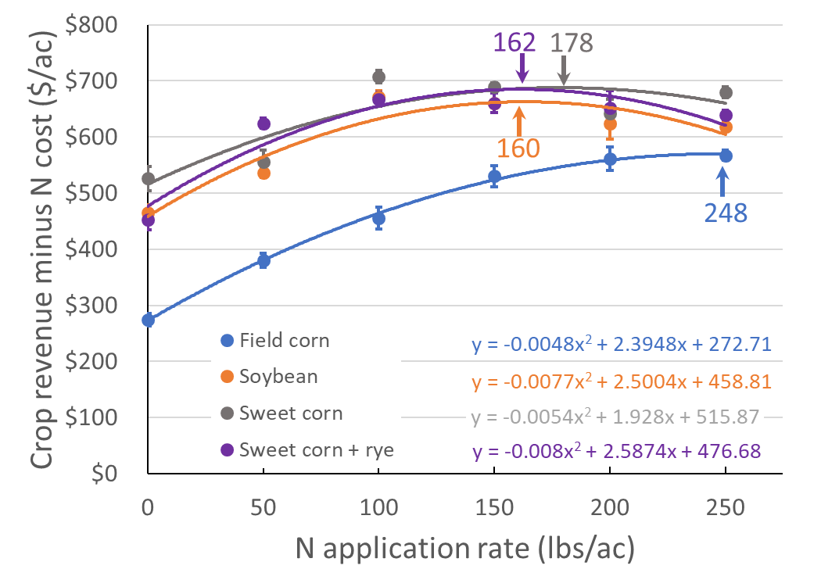
Figure 1. Field corn crop revenue in Field 1 in 2018 as a function of the application rate of N, used to calculate the economically optimum N rate (EONR). The data for each prior rotation crop was fitted with a quadratic function and the peak of the function was identified as the location where the change in crop revenue minus N cost with a change in N rate equaled zero. The N rate at which this occurred is given as a number adjacent to an arrow indicating the location of the curve peak. This model assumes that field corn sells for $3.66 per bushel and urea for $0.17 per pound (actual November 2018 prices). Error bars indicate the standard error of the mean.

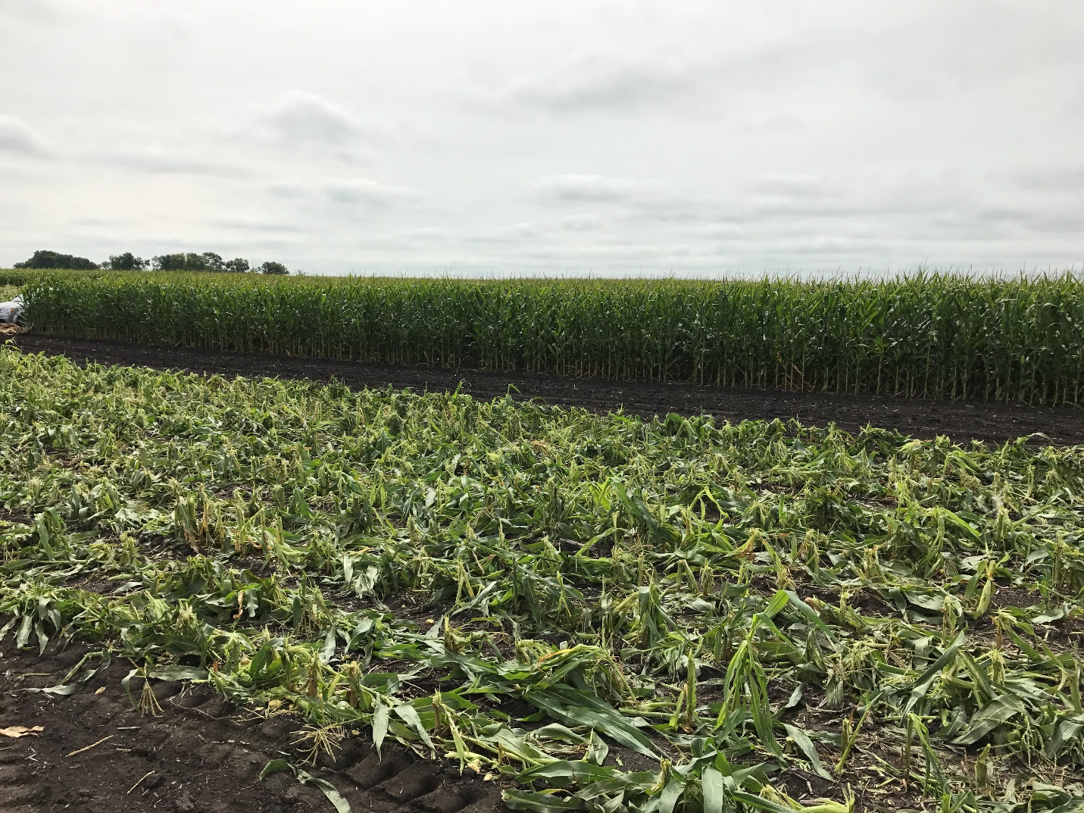

Figure 2. Sweet corn following mechanical harvest, August 15, 2017. No other field operations were performed between harvest and planting rye. (Photo credit Charlie Rohwer)

Figure 3. Grain drill used to plant rye. (Photo credit Charlie Rohwer)
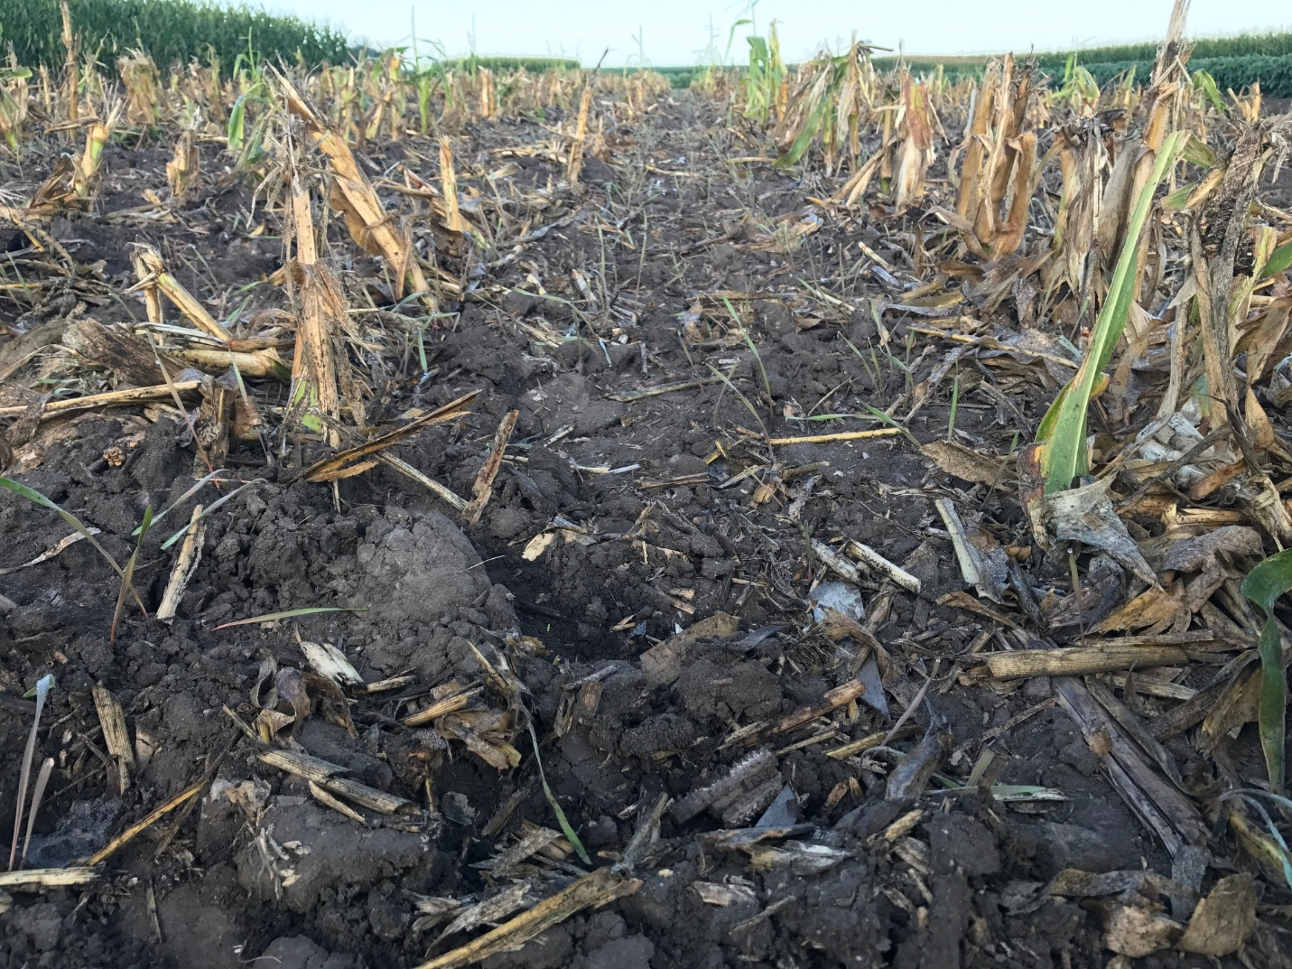

Figure 4. Harvested sweet corn field planted with winter rye. Rye is emerging – September 7, 2017. (Photo credit Charlie Rohwer)

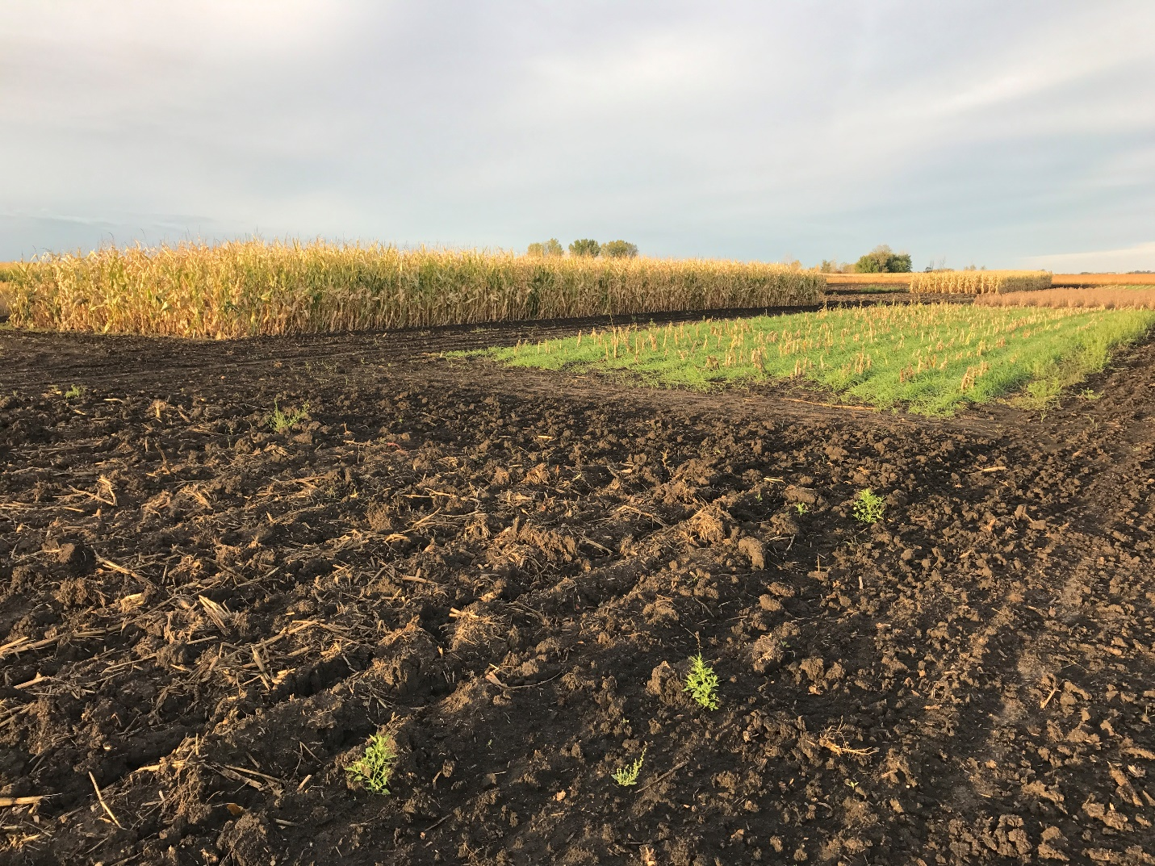

Figure 5. Rye growth on October 10, 2017. (Photo credit Charlie Rohwer)
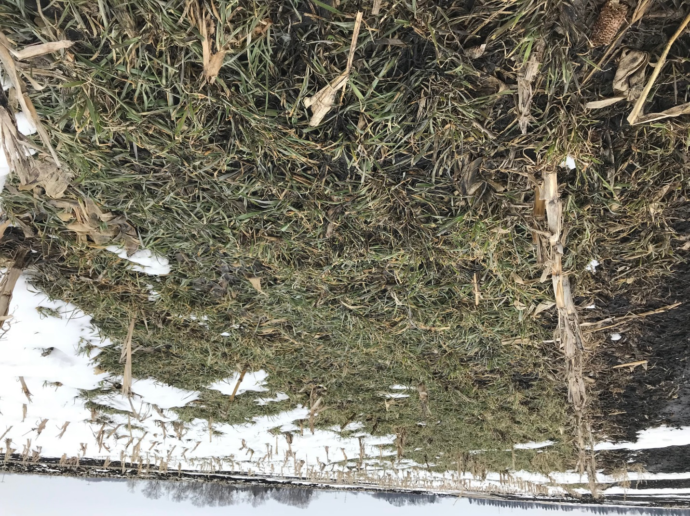

Figure 6. Rye cover crop April, 10, 2018. (Photo credit Charlie Rohwer)

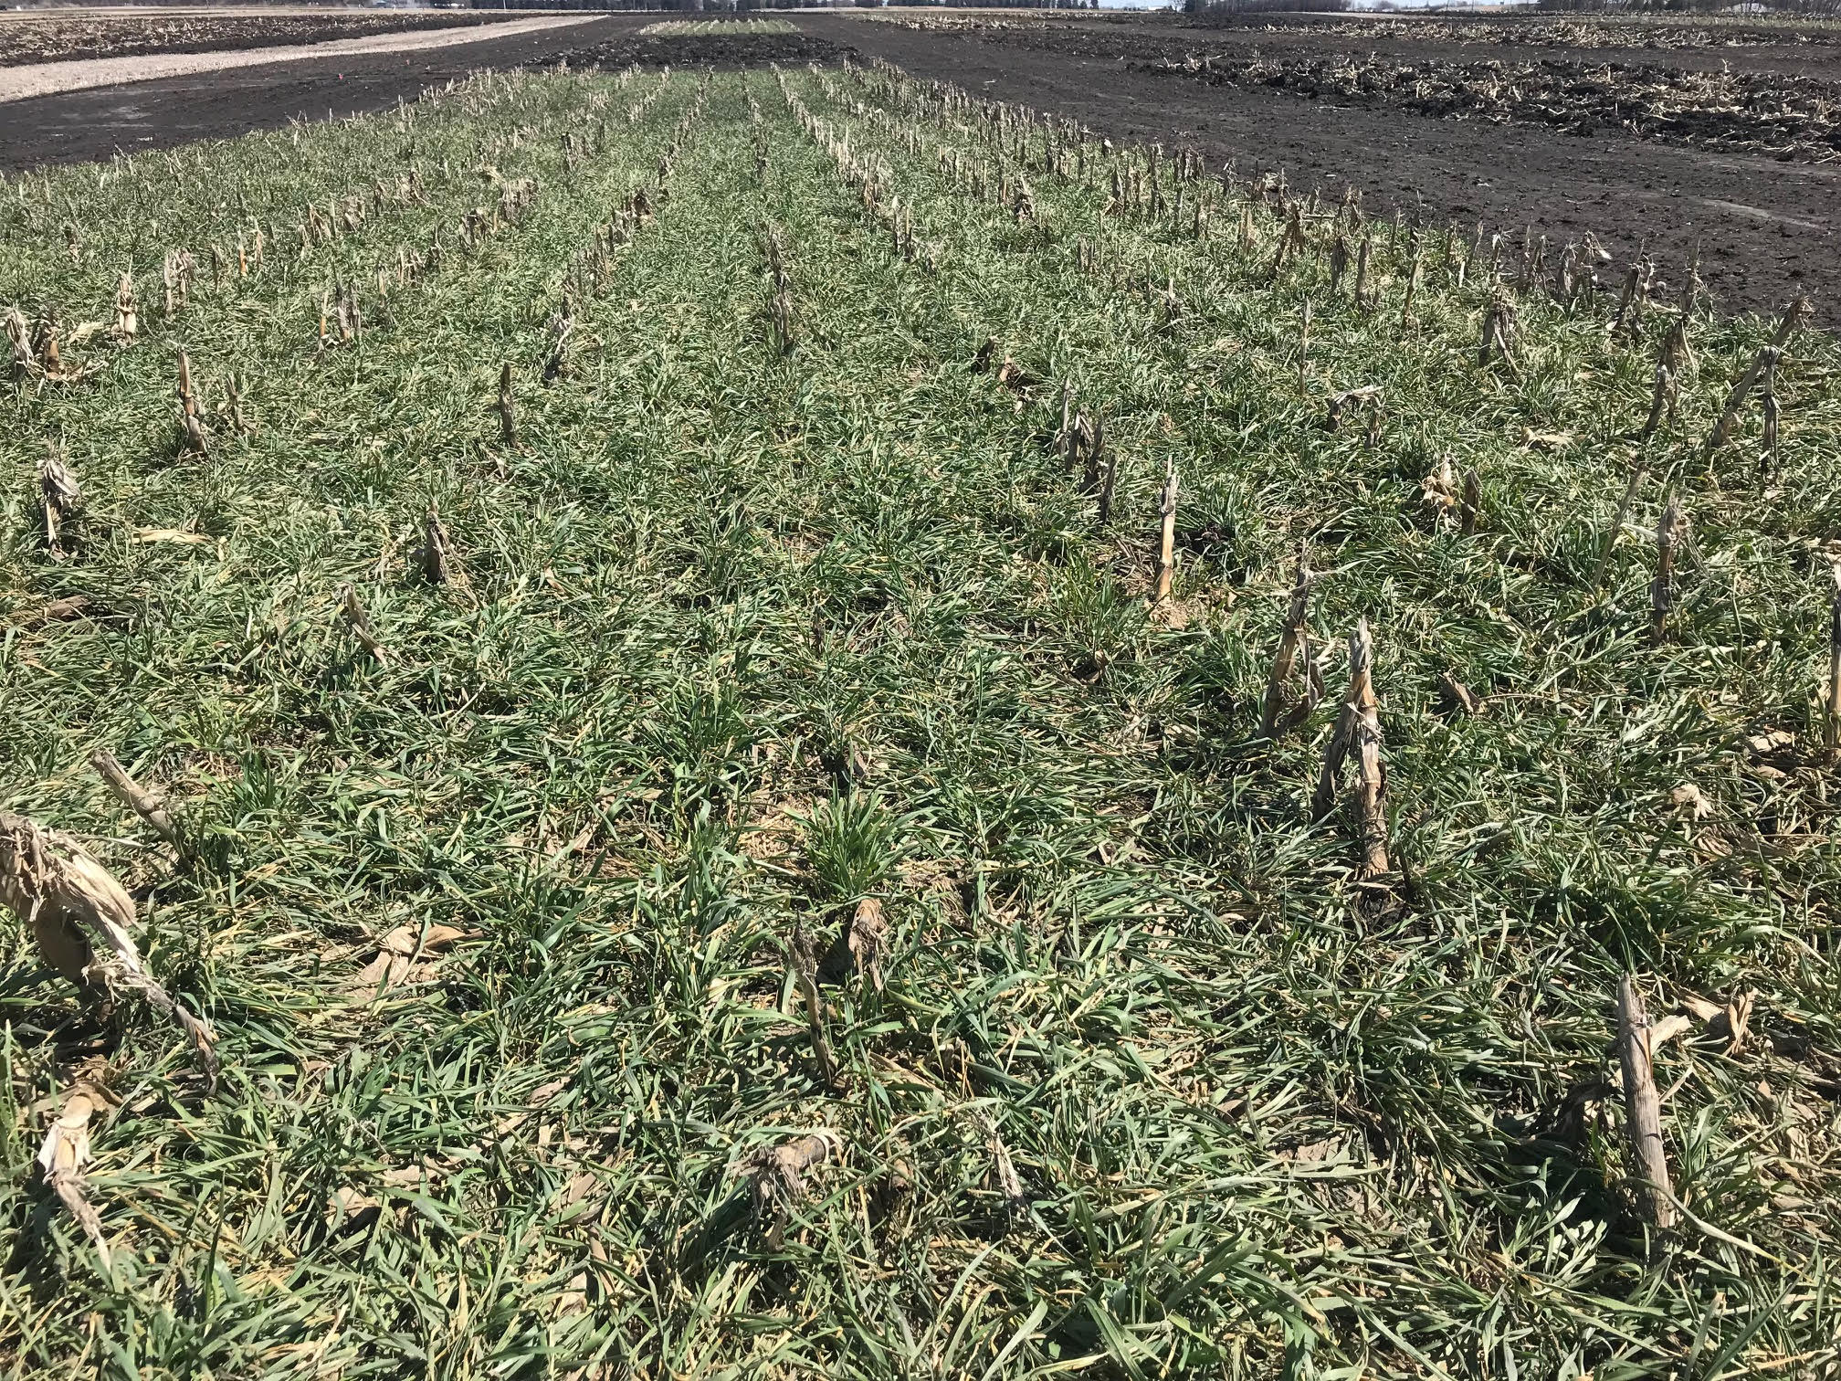

Figure 7. Rye cover crop April 25, 2018. (Photo credit Charlie Rohwer)

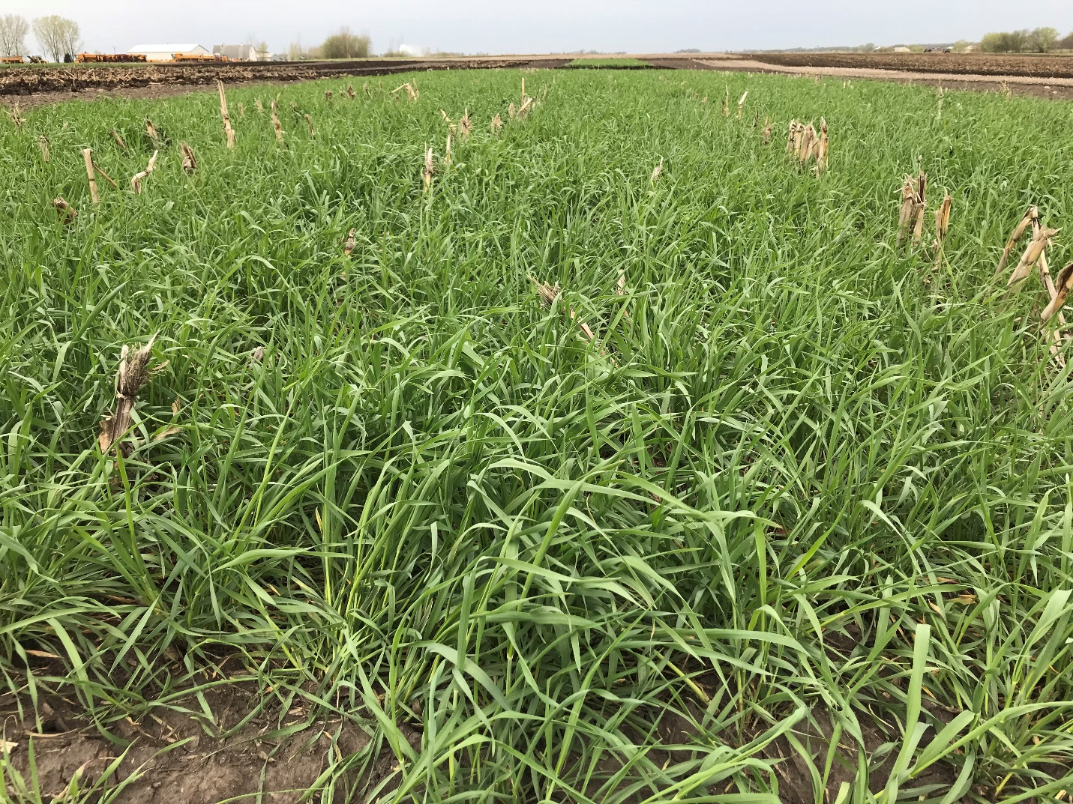

Figure 8. Rye cover crop May 8, 2018 just prior to disking on May 10. The rye was then sprayed with glyphosate on 15 May and disked again on May 18. (Photo credit Charlie Rohwer)

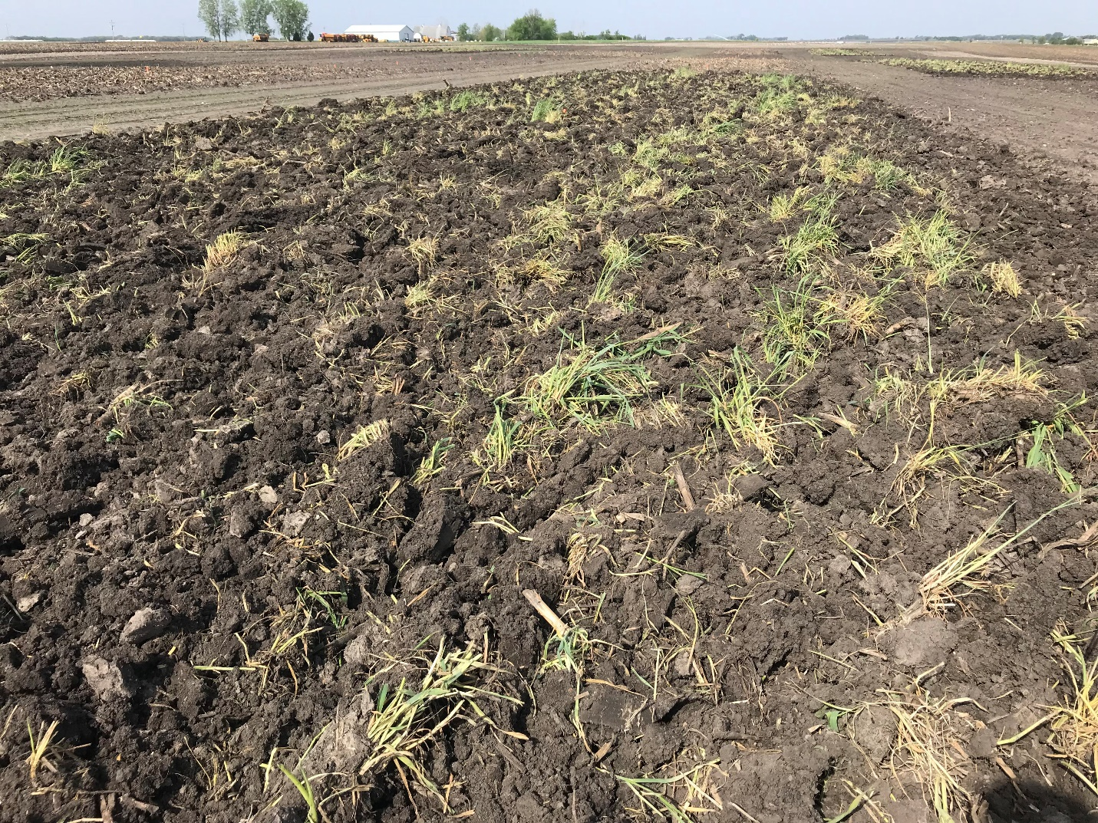

Figure 9. Rye cover crop killed with glyphosate followed by disking May 18, 2018. Field corn was planted May 21, 2018. (Photo credit Charlie Rohwer)

