Nitrate in Tile-Drain Water Relative to Time and Source of Nitrogen Application
2018

Fabián Fernández, Paulo Pagliari, and Jeffrey Strock

Summary
Sound nitrogen (N) management is a key component to minimizing environmental degradation and improving farmer’s profitability. Nitrogen fertilization in agricultural lands in much of the Midwest has been linked to water quality issues related to the hypoxia zone in the Gulf of Mexico. Currently, Minnesota and other Midwestern states have or are developing Nutrient Reduction Strategies to reduce nitrate loads. While we have learned much about some of the practices that can help us achieve reductions in nitrate loads to the Mississippi river, still there are many uncertainties on how well some N management practices work. Further, other practices, such as in-season applications, split pre-plant plus sidedress applications, or the use of controlled release fertilizers, have not been evaluated to truly determine their value for agronomic and water quality goals. It is clear that substantial research efforts are needed in order to provide meaningful and reliable guidance to enhance agricultural productivity in Minnesota while protecting the environment.

Introduction
Nitrogen is extremely important for optimizing corn yield as this crop has a large requirement for this nutrient. At the same time, N is important from an environmental standpoint as this nutrient can have profound negative impacts on environmental quality when introduced into surface- and ground-water or the atmosphere in the form of nitrous oxide. Nitrogen fertilization in agricultural lands in much of the Midwest has been linked to water quality issues related to the hypoxia zone in the Gulf of Mexico. Currently, Minnesota and other Midwestern states are developing Nutrient Reduction Strategies to reduce nitrate loads by 45% by the year 2045. In order to achieve this lofty goal, much needs to be done with research to determine how effective various traditional and new N-management practices are.

Although during the early development stages corn does not grow vigorously and does not require large amounts of N, this nutrient is typically applied prior to planting to ensure season-long N availability for the crop. Early spring is also the time when normally there is greater potential for N loss through tile-drainage as the soils tend to be saturated with water and precipitation exceeds crop needs. While several projects in the past have studied the impact of fertilizer rate and fall and spring fertilizer timing on nitrate leaching, there has been relatively little effort devoted to quantifying the effect of time of application on water quality when nitrogen is applied at sidedress (typically when corn is at the 2- to 4-leaf stage) or split-applied between a pre-plant and a sidedress application. Further, less is known about the potential of polymer coated urea (or controlled-release fertilizers) to improve N availability for the crop while minimizing the risk of environmental degradation. Delaying the application of fertilizer to sidedress time, splitting the application between pre-plant and sidedress, or applying a polymer coated urea product could reduce potential losses in early spring when N loss potential is typically highest. However, delaying the application or using controlled-release fertilizers can have similar negative effects if the crop does not have the N that it needs to optimize productivity. When this occurs, not only yield and profitability are diminished, but the N that was not used to make yield can potentially be lost to the environment later. It is clear that while we have learned much about some of the practices that can help us achieve reductions in nitrate loss to the environment, still there are many uncertainties on how well some N management practices work. Further, other practices have not been evaluated to truly determine their value for agronomic and water quality goals. This illustrates that substantial research efforts are needed in order to provide meaningful and reliable guidance to enhance agricultural productivity while protecting the environment.

Goals and Objectives
The goal of this project is to characterize the potential benefits of utilizing current technologies in innovative ways to improve water quality and crop yield. The objectives of this study are to 1) quantify the effect of timing of N application and N sources on nitrate concentration and load in tile-drain water, and 2) quantify nitrogen use efficiency in terms of corn N uptake and yield based on fertilization management.

Materials and Methods
The field was in soybeans during 2013 and had not been used for research purposes for approximately 7 years. This project started in spring 2014—and is ongoing— at the Southwest Research and Outreach Center at Lamberton (SWROC) on a Webster clay loam soil (fine loamy, mixed, mesic Typic Haplaquoll) that is a common series in the Minnesota river basin. The plow layer has a clay loam texture (36% sand, 35% silt and 25% clay). The study is using existing tile-drain plots established in 1994. The study site consist of 16 plots, each 30 feet wide (12 crop rows wit 30-inch spacing) by 60 feet long. Each plot is individually drained with a 4-inch tile line 4 feet below the surface and 5 feet from the plot width edge to simulate a 110 feet tile spacing. To prevent lateral water movement each plot is isolated by a 6 feet deep plastic (0.03 mm thickness) barrier. In 2018, we changed the way water samples are collected. The drainage flow from each plot is now continually measured at monitoring wells with pumps and flow meters. A flow-proportionate sample is collected every time there is flow with a sideline fitted to an orifice in one end and a collection container in the other end.

Starting in 2014 a continuous corn cropping system was established. Four treatments of 180 lb N acre⁻¹ were arranged in a randomized complete block design with four replications: pre-plant urea, pre-plant ESN, and split-applied with N rate at one-third pre-plant/two-third sidedress at V4 of urea/urea and ESN/urea.

Pre-treatment soil conditions (0-12, 12-24, and 24-36 inch) were assessed with samples collected on 23 May 2014, 8 May 2015, 29 Mar 2016, 24 April 2017, and 15 May 2018. Pre-plant treatments were applied 23 May 2014, 9 May 2015, 6 May 2016, 24 April 2017, and 31-May 2018 and incorporated by tillage within 24 hrs. Corn hybrid (DeKalb DKC49-29 RIB) was planted on 25 May 2014 and 9 May 2015 and thinned to 32,000 plants/acre; corn hybrid (Pioneer P0157 AMX) was planted on 16 May 2016 and 6 May 2017 and thinned to 34,000 plants/acre; and corn hybrid (DKC 39-27 RIB) was planted on 31 May 2018 at 35,000 seeds/acre. Sidedress treatments were applied on 16 June 2014, 18 June 2015, 16 June 2016, 22 June 2017, and 21 June 2018 at the V4 development stage in all years except 2017 and 2018 where the crop was at the V6 development stage.

In 2014 whole plant samples for total N analysis, soil samples (0-12 and 12-24 inch) for NH₄⁺ and NO₃⁻ analysis, and SPAD meter scans were collected at V8, V12, and R1 development stage on 8 July, 28 July, and 7 August, respectively. The same sampling was done in 2015 to 2017 at V4, V8, V12, and R1 on 18 June 2015, 2 July 2015, 15 July 2015, and 29 July 2015, respectively; on 16 June 2016, 5 July 2016, 20 July 2016, and 1 August 2016 respectively; and on 9 June 2017, 29 June 2017, 11 July 2017, and 26 July 2017 respectively. In 2018 the soil, plant, and canopy sensing with SPAD measurements were collected at V6 on 27 June, V10 on 16 July, and R1 on 31 July. Whole plant samples at R6 development stage for total N analysis were collected on 9 October 2014, 28 September 2015, 4 October 2016, 19 September 2017, and 24 September 2018. Grain harvest was done on 24 October 2014, 16 October 2015, 19 October 2016, 20 October 2017, and 22 October 2018. Each year the center four rows of each plot were harvested except in 2017 where only the center two rows were harvested. Post-harvest soil samples for NH₄⁺ and NO₃⁻ analysis were collected 7 November 2014, 3 November 2015, 7 November 2016, 13 November 2017, and 22 October 2018.

During 2014, we installed the tile drain water sampling equipment and no drainage occurred the rest of that growing season or in the fall. In 2015, there was limited (inconsistent) amount of drainage, as substantial amount of precipitation was needed to recharge the soil profile, which was dry from the previous year, before drainage occurred. In fall 2015, we were able, for the first time, to measure drainage. The samples were analyzed for nitrate concentration and those data along with water flow rates were used to calculate total nitrate loads. While there was variability in the amount of monthly flow, in 2016 we measured flow every month from March to November, in 2017 from April to December, and in 2018 from April to November.

Data were analyzed using the GLIMMIX procedure of SAS.

Results and Discussion
During the 2018 growing season, precipitation was below normal in April, near normal in August and above normal the rest of the growing season (Table 1). June, July, and September had substantially more precipitation than normal and the overall growing season (Apr-Oct) precipitation was 232 mm (9.1 in) above normal. Mean monthly air temperatures were substantially cooler than normal in April and October and May through September had above normal temperatures except for July where temperatures were near normal (Table 1).

Mean grain yield starting with the 2014 growing season have been 153, 164, 169, 212, and 163 bu/ac. The overall warm and moist growing season likely helped to compensate for the late planting due to wet conditions in the spring of 2018. The pre-plant urea treatment had significantly (p=0.1) less yield (152 bu/ac) than the other treatments that had similar yields (range of 162-172 bu/ac) (Fig. 1). In 2018, there was substantial precipitation in May through July and the potential for N loss was large (Table 1). For this reason, it is likely that we observed lower yields with pre-plant urea. Conversely, applying ESN pre-plant helped improve grain yield (172 bu/ac) as this form of N was likely protected from loss early in the season. This year as well as previous year, the general trend has been for treatments containing ESN to produce greater yields than treatment without ESN for the same application timing. We also observed averaged across years that pre-plant urea produced the lowest yield (166 bu/ac). The trend for greater yield with ESN in pre-plant applications was also observed with the split applications where the treatment with ESN produced 168 bu/ac (6 bu/ac more than the urea split application). Since the only difference between the two split application treatments was the N source at pre-plant, the observed trend may hint that selection of an appropriate N source to protect against N loss early in the season may be an advantageous practice.

In most years, water deficit is an important limiting factor for corn production in Lamberton. That was not the case this year. During critical corm development stages that occurred during July and August there was adequate precipitation (Table 1). Plant N uptake increased from V6 to R1 development stage (table 2). The pre-plant treatments had more N accumulated than the split application treatments at V6, likely because there was more N available with the pre-plant treatments where the full rate (180 lb N/ac) was already applied. However, by V10 and R1 the split application treatments had more N accumulated. By harvest time, the total N accumulated (tissue at R6 plus grain) was lower for the pre-plant urea treatment relative to the other treatments. Correlation of SPAD values to grain yield were poorly correlated, though the correlation improved over the growing season with R² values of 0.14, 0.41, and 0.43 for V6, V10, and R1, respectively (data not shown). This is similar to what was observed in previous years.

Another important aspect of this project is linking N management to water quality. This year we had very wet conditions in June, July, and September (Table 1). Nitrate concentrations were relatively typical (Table 2). However, the mean cumulative load was similar for all treatments except for ESN pre-plant that had substantially lower concentrations compared to ESN/Urea. The other treatments were numerically high, but not statistically different from ESN pre-plant. This was because of substantial variability. That said, these results should be considered preliminary at this time, as the data are still been analyzed and scrutinized for errors and adjustments that are often needed when highly variable flow and concentration values are continuously collected. Nonetheless, it is clear that ESN seems to reduce N loss by leaching in years with substantial early season precipitation. The lower N loss follows great grain yields observed in this year, as previously mentioned. Most of the nitrate loss happened in late June/early July when there was substantial precipitation. Later in July, while there was substantial precipitation, nitrate leaching was very small as the crop was using substantial amounts of water and precipitation did not exceed the storage capacity of the soil. In September when the crop was no longer growing and again we experienced substantial precipitation, nitrate leaching once again increased.

Residual soil N (ammonium and nitrate) was low at the end of the previous growing season with nitrate-N in the top 12 inches being highest in general (Fig. 3 left graph). In previous years, we observed that ammonium-N was generally greater. It is likely that in 2018 there was sufficient moisture and warm temperatures to convert ammonium produced through mineralization of organic matter to nitrate. Residual soil N was very low before treatment applications and most of the N was ammonium-N in the top 12 inches of the soil (Fig. 4). At V6 development stage the pre-plant treatments show high levels of nitrate-N in the top 24 inches of the soil indicating that the fertilizer had been largely nitrified (ammonium-N levels are similar to the split application treatments) (Fig. 4). By V10, development stage there was more soil N for the split application treatments than the pre-plant treatments (Fig. 4). By R1, there was very low soil N and ammonium-N in the top 12 inches of the soil was the most important form of N for all treatments, likely indicating mineralization. By fall, the post-harvest soil data (Fig. 3 right graph) show very low amounts of N regardless of treatment. Normally at this sampling time, it is common to observe some mineralized N that increases soil N levels because the potential for N loss is low and the crop is no longer taking up N. However, in 2018 we observed that during September and October there was some important amount of nitrate-N leaching in the tile lines due to the large amount of precipitation received.

Finally, this year as part of a large Midwest regional study we included nitrous oxide measurements in this study. The results were similar to what we observed with nitrate leaching in that ESN pre-plant had the lowest cumulative flux compared to the other three treatments (Fig. 5). These data clearly show an advantage to using ESN during wet years. It was clear that pre-plant urea suffer substantial N loss as nitrous oxide soon after the application while pre-plant ESN and the split applications were very low. Unfortunately, soon after the split applications were done, we received substantial precipitation and both split application treatments loss substantial amounts of N (similar to the pre-plant urea treatment during early July). These data along with the nitrate leaching data and the fact that ESN pre-plant had the highest yield highlight that this N source may be a beneficial source during wet springs. Nitrous oxide emissions in conjunction with the measurements we were already collecting make this a unique and valuable study as scant data are available where both measurements are done at the same time.
Table 1. Mean monthly air temperature and mean monthly cumulative precipitation for the 30-yr normal and the 2018 growing season at Lamberton, MN.
Year | Apr | May | Jun | Jul | Aug. | Sep | Oct. | Apr-Oct Cumm.
 | Precipitation (mm)
30-yr normal | 76 | 87 | 105 | 99 | 102 | 77 | 51 | 597
2018 | 45 | 115 | 182 | 157 | 92 | 167 | 71 | 829
 | Temperature (˚C)
 | Apr | May | Jun | Jul | Aug. | Sep | Oct. | Apr-Oct Cumm. Ave.
30-yr normal | 7.5 | 14.4 | 20.3 | 22.5 | 20.6 | 16.1 | 9.2 | 15.8
2018 | 0 | 18.1 | 21.9 | 22.2 | 21.1 | 17.5 | 6.1 | 15.3

Table 2. Total plant nitrogen uptake in vegetative tissues (no ear) at different development stages and grain at harvest for different N sources (urea and ESN) and different times of application (180 lb N/ac pre-plant or 60 lb N/ac pre-plant and 120 lb N/ac applied at V4 development stage) for the 2018 growing season.
Treatment | V6 | V10 | R1 | R6 | Grain
 | lb N/ac
Urea | 7 | 52 | 78 | 54 | 92
ESN | 7 | 55 | 81 | 53 | 103
Urea/Urea+ | 4 | 68 | 94 | 53 | 109
ESN/Urea+ | 5 | 61 | 97 | 53 | 114

Table 3. Treatment minimum, maximum, and mean nitrate-N concentrations measured during flow events and mean season-long cumulative load for 2015 to 2018 growing seasons.
Treatment | _____Min_____ |  |  |  | _____Max_____ |  |  |  | _____Mean_____ |  |  |  | _____Mean_____
 | 2015 | 2016 | 2017 | 2018 | 2015 | 2016 | 2017 | 2018 | 2015 | 2016 | 2017 | 2018 | 2015 | 2016 | 2017 | 2018
 | _____________________________________________mg/L_____________________________________________ |  |  |  |  |  |  |  |  |  |  |  | __________lb/ac__________
Urea | 1.6 | 6.9 | 1.4 | 1.4 | 18.9 | 19.6 | 149.2 | 17.6 | 9.8 | 13.0 | 23.5 | 7.7 | 6b | 23a | 24a | 32ab
ESN | 1.7 | 7.3 | 0.7 | 2.0 | 19.1 | 23.6 | 129.5 | 18.5 | 7.3 | 13.5 | 17.4 | 6.4 | 4b | 17a | 15a | 16b
Urea/Urea+ | 1.6 | 6.5 | 1.7 | 3.2 | 31.0 | 20.5 | 150.8 | 16.4 | 10.3 | 11.8 | 27.1 | 8.0 | 10a | 22a | 19a | 26ab
ESN/Urea+ | 0.9 | 7.4 | 1.2 | 0.9 | 17.7 | 18.3 | 129.5 | 17.2 | 10.1 | 11.5 | 31.9 | 7.0 | 5b | 15a | 22a | 39a
Values followed by the same letter within year are not significantly different (P>0.1)

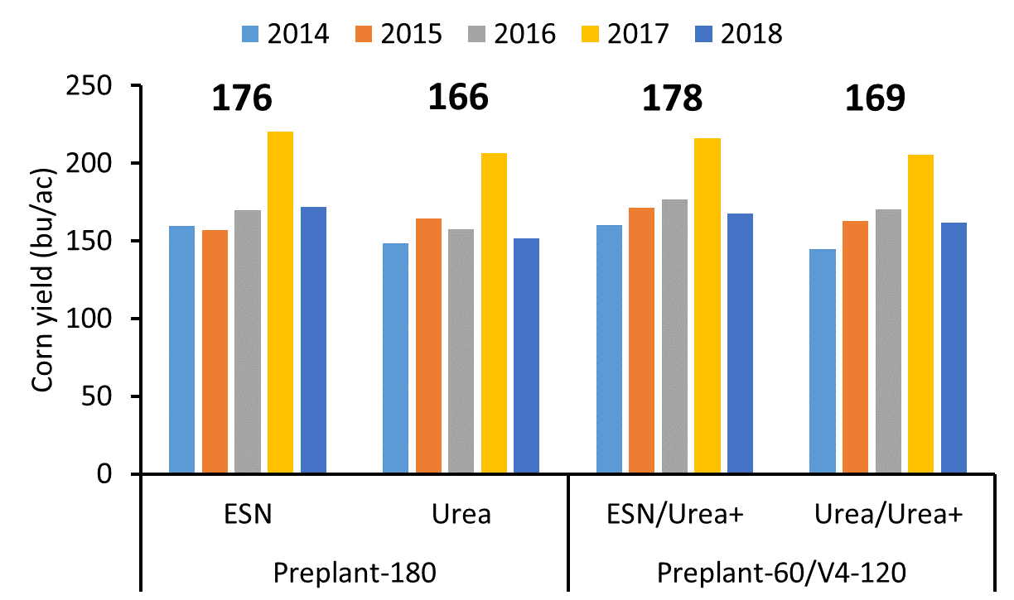
Figure 1 Grain yield for different N sources (urea and ESN) and different times of application (180 lb N/ac pre-plant or 60 lb N/ac pre-plant and 120 lb N/ac applied at V4 development stage) for 2014 to 2018 growing seasons.

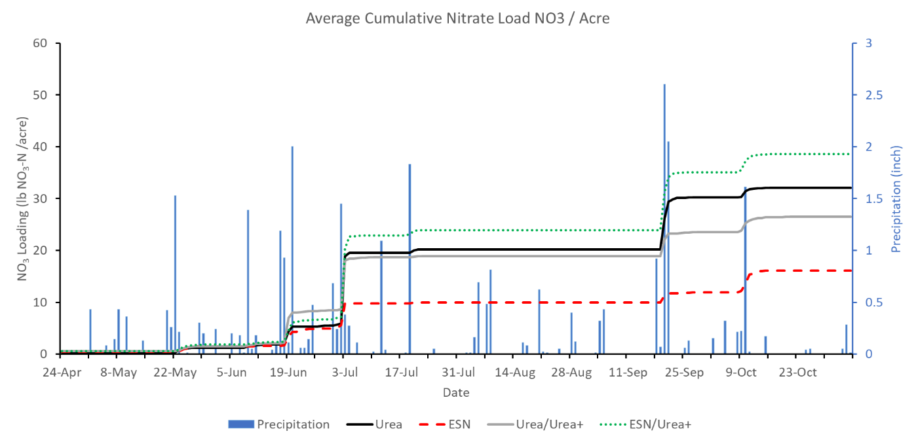
Figure 2 Cumulative nitrate loading across the 2018 growing season as affected by treatment: different N sources (urea and ESN) and different times of application (180 lb N/ac pre-plant or 60 lb N/ac pre-plant and 120 lb N/ac applied at V4 development stage.

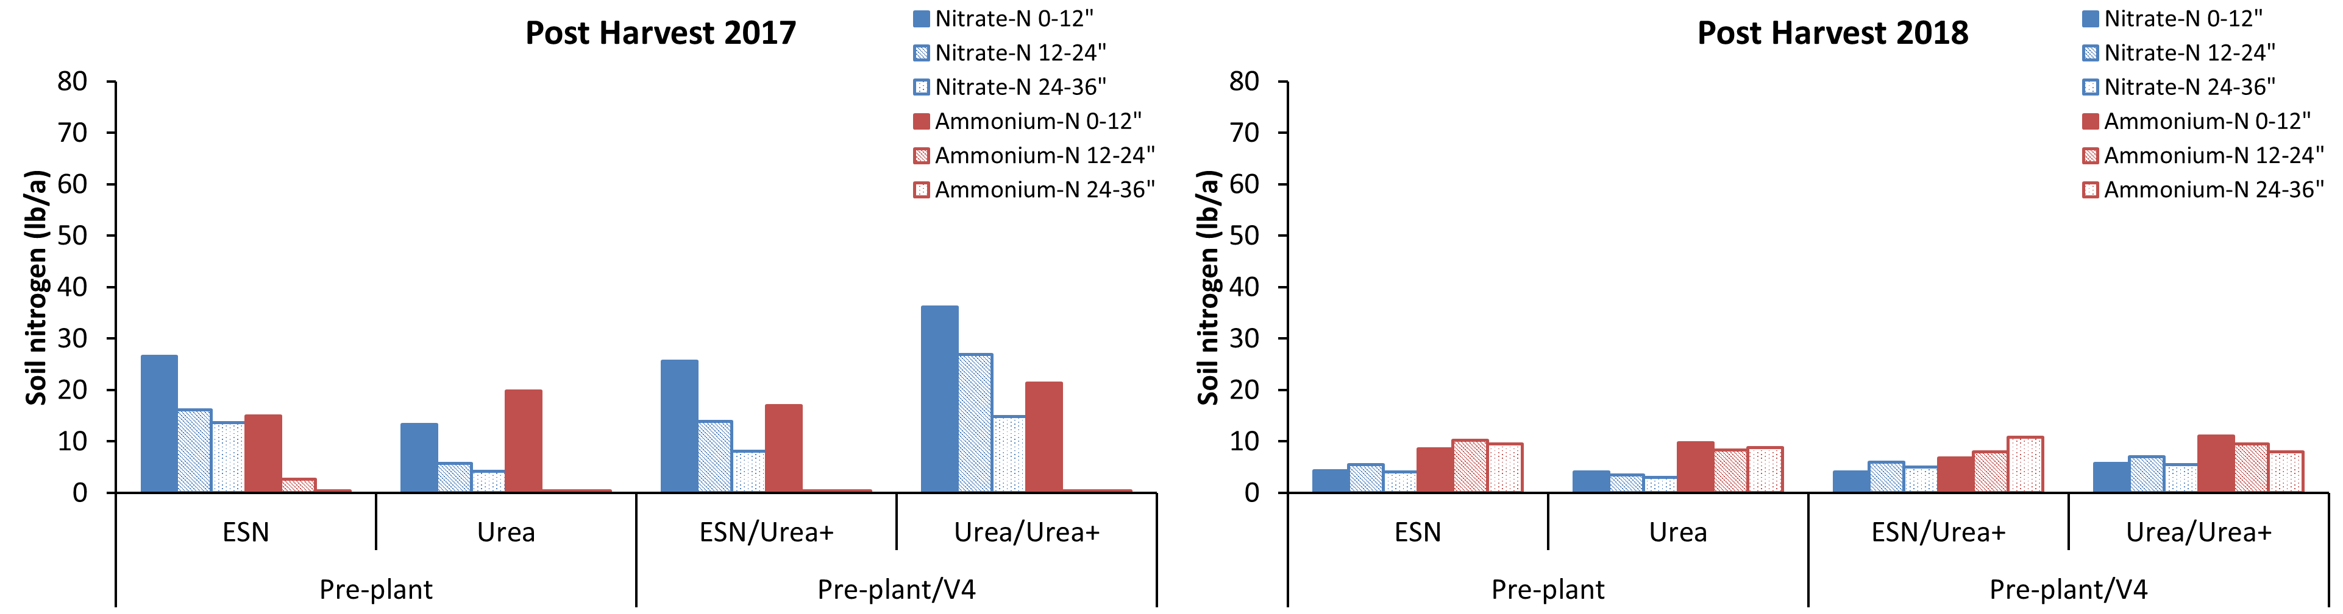Figure 3. Residual soil nitrogen for various soil depths at the end of the 2017 and 2018 growing seasons for the various treatments: different N sources (urea and ESN) and different times of application (180 lb N/ac pre-plant or 60 lb N/ac pre-plant and 120 lb N/ac applied at V4 development stage.

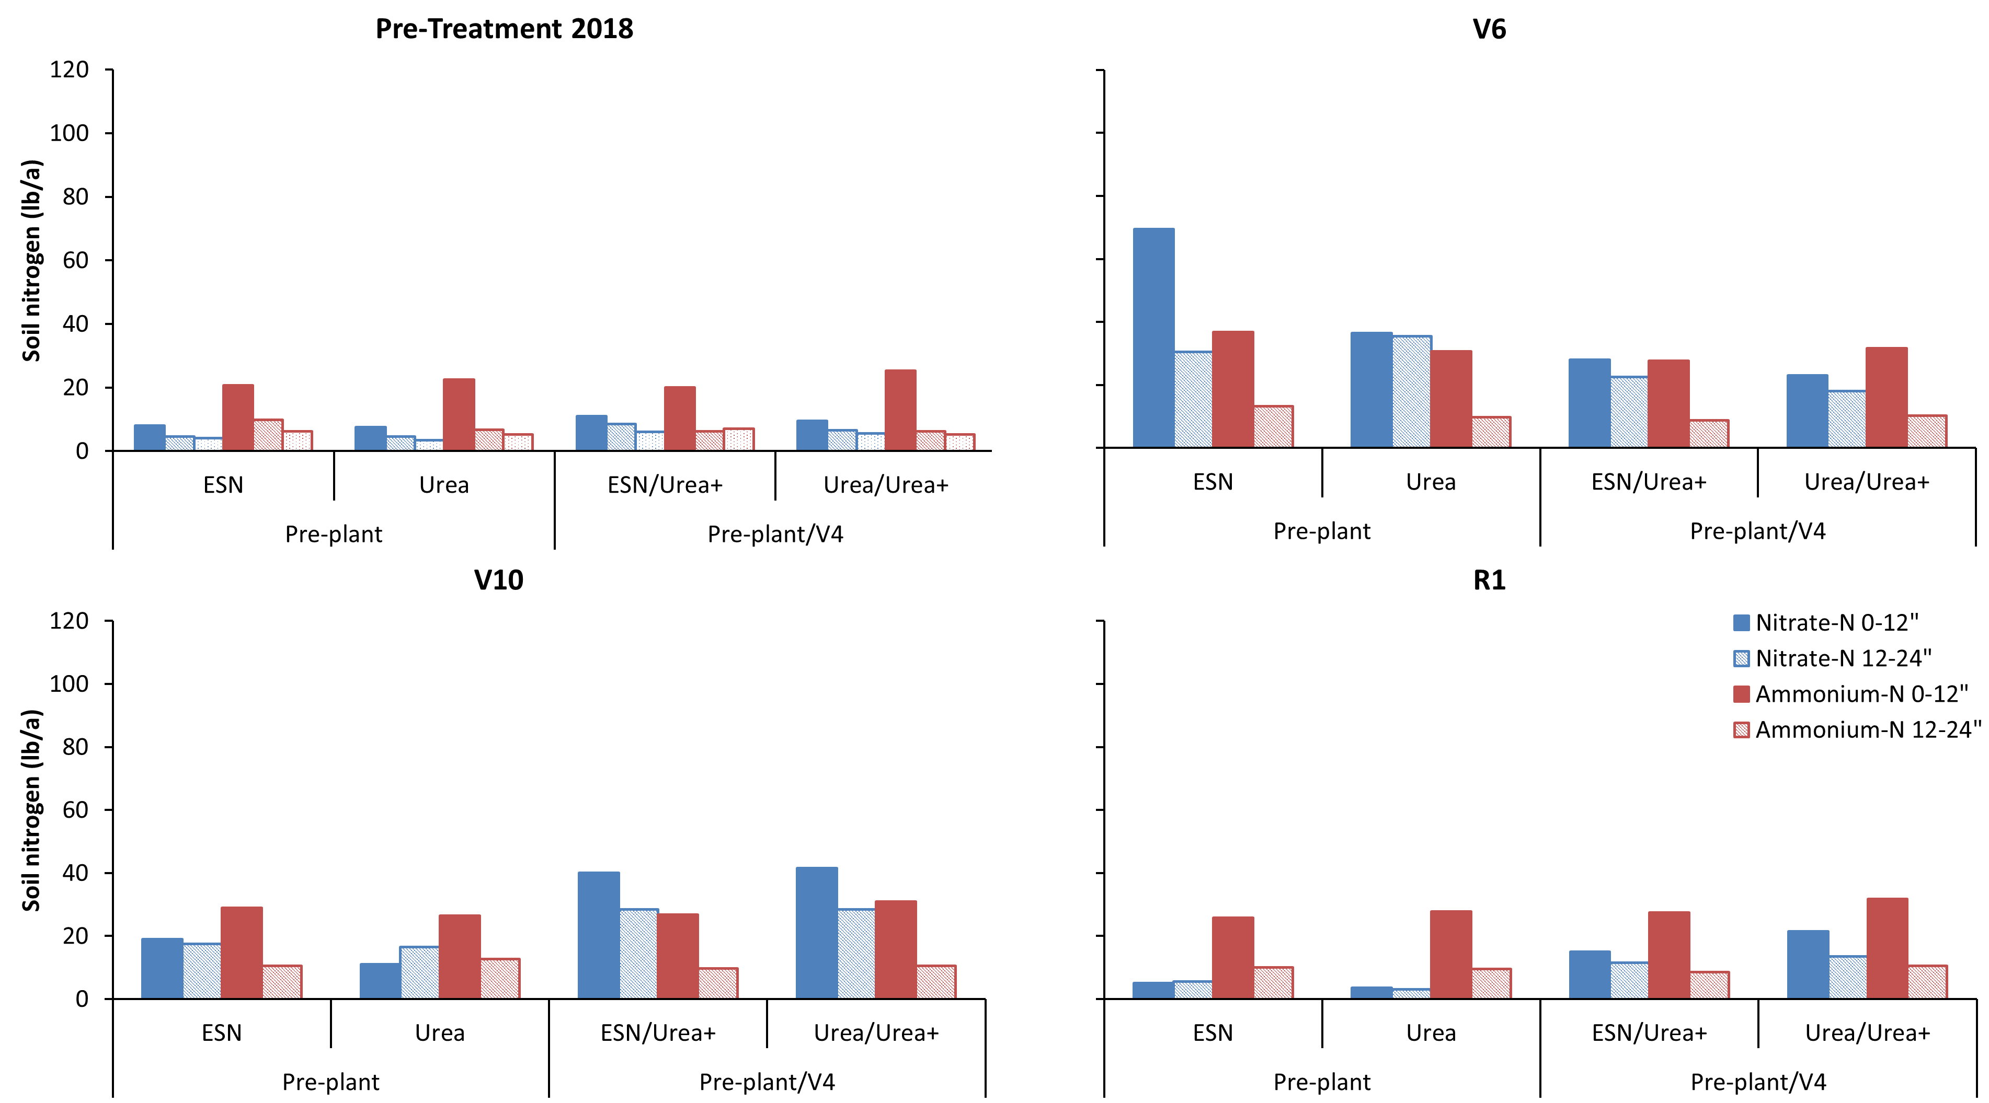
Figure 4. Soil nitrogen for various soil depths across the 2018 growing season as affected by treatment: different N sources (urea and ESN) and different times of application (180 lb N/ac pre-plant or 60 lb N/ac pre-plant and 120 lb N/ac applied at V4 development stage.

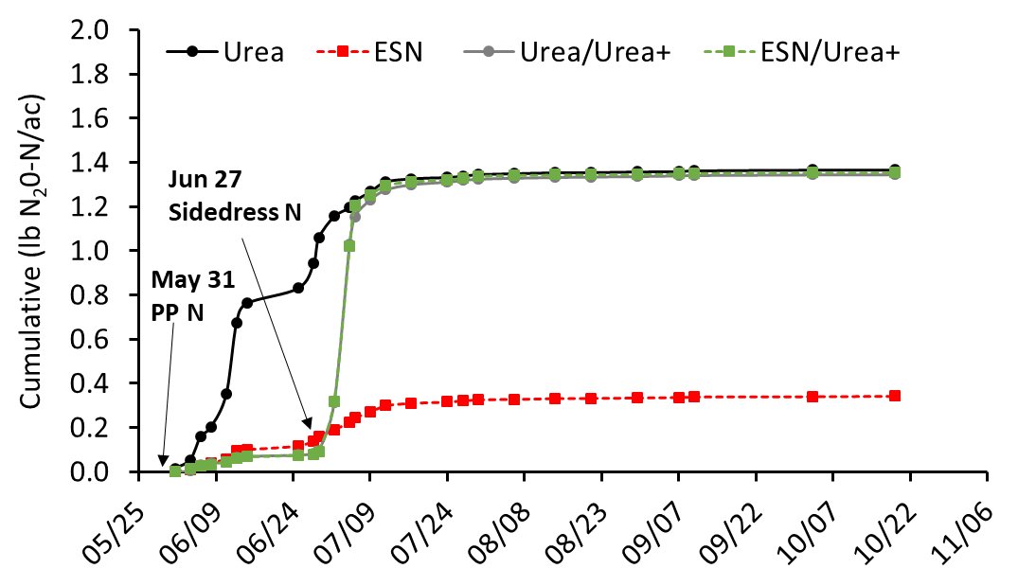
Figure 5. Cumulative nitrous oxide emissions across the 2018 growing season as affected by treatment: different N sources (urea and ESN) and different times of application (180 lb N/ac pre-plant or 60 lb N/ac pre-plant and 120 lb N/ac applied at V4 development stage.

